**LAB 28 – Pandas Data Analysis**

**Lab1: Write a Pandas program to split the following data frame into groups based on Class and count the number of students in that particular class. Also generate a bar chart based on the result and explain the conclusion.**

**Input:** student_data = pd.DataFrame({ 'school_code': ['s001','s002','s003','s001','s002','s004'], 'class': ['V', 'VI', 'VI', 'VI', 'V', 'VI'], 'name': ['Alberto Franco','Gino Mcneill','Ryan Parkes', 'Eesha Hinton', 'Gino Mcneill', 'David Parkes'], 'age': [12, 12, 13, 13, 14, 12], 'height': [173, 192, 186, 167, 151, 159], 'weight': [35, 32, 33, 30, 31, 32], 'address': ['street1', 'street2', 'street3', 'street1', 'street2', 'street4']}, )

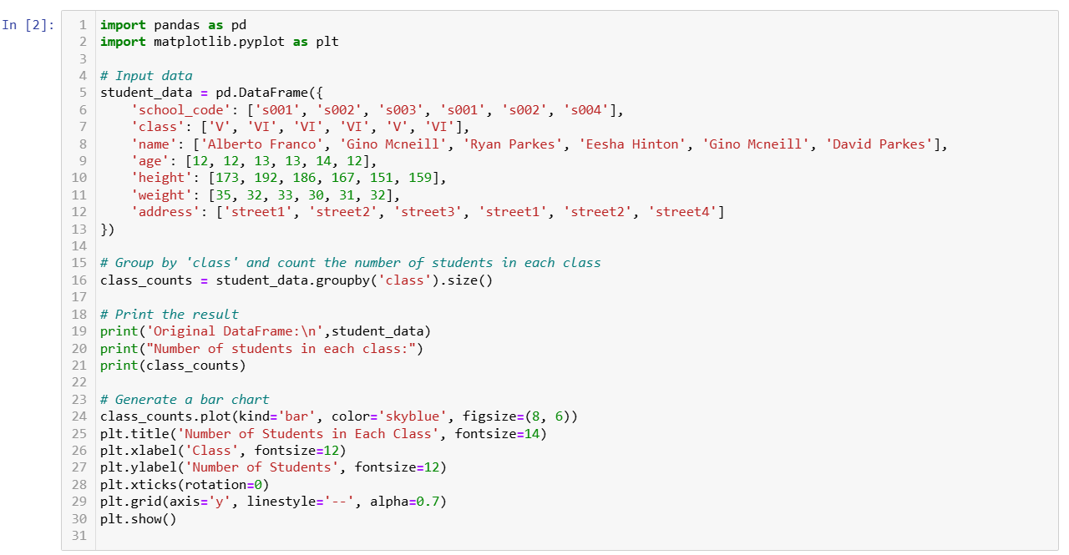

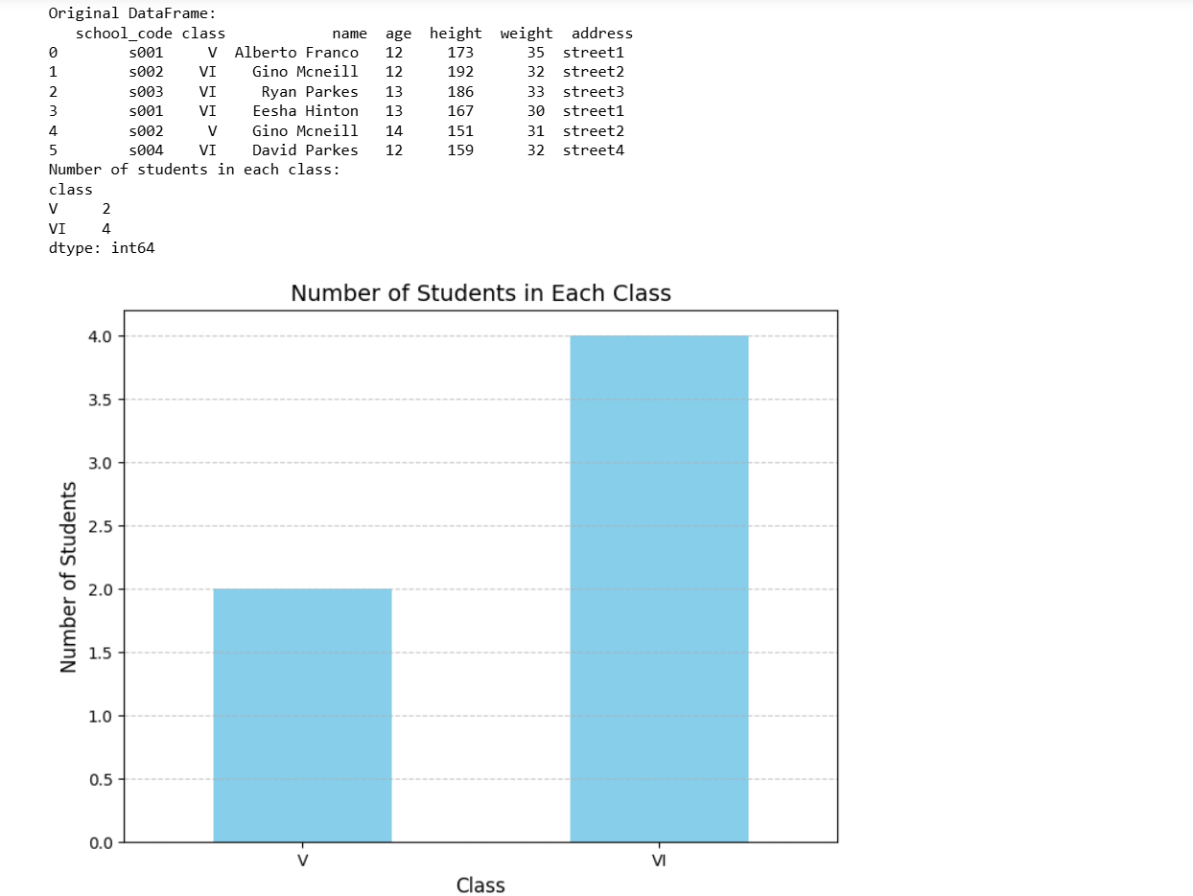

**Lab2: Write a Pandas program to split the following dataframe by school code and get mean, min, and max value of age for each school. Also generate a horizontal bar chart based on the result and explain the conclusion.**

**Input**: student_data = pd.DataFrame({ 'school_code': ['s001','s002','s003','s001','s002','s004'], 'class': ['V', 'V', 'VI', 'VI', 'V', 'VI'], 'name': ['Alberto Franco','Gino Mcneill','Ryan Parkes', 'Eesha Hinton', 'Gino Mcneill', 'David Parkes'], 'age': [12, 12, 13, 13, 14, 12], 'height': [173, 192, 186, 167, 151, 159], 'weight': [35, 32, 33, 30, 31, 32], 'address': ['street1', 'street2', 'street3', 'street1', 'street2', 'street4']}, )

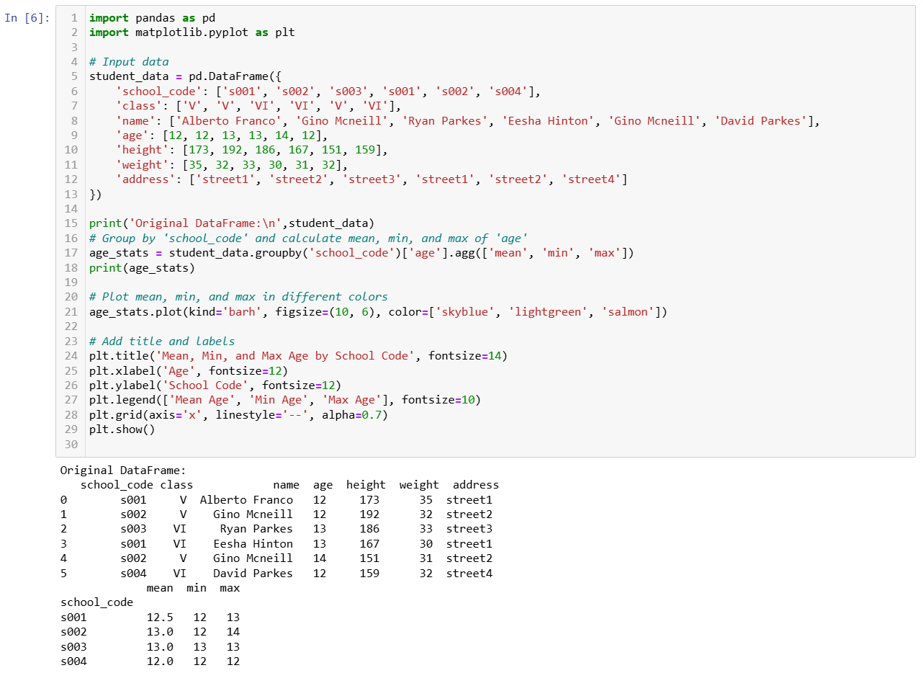

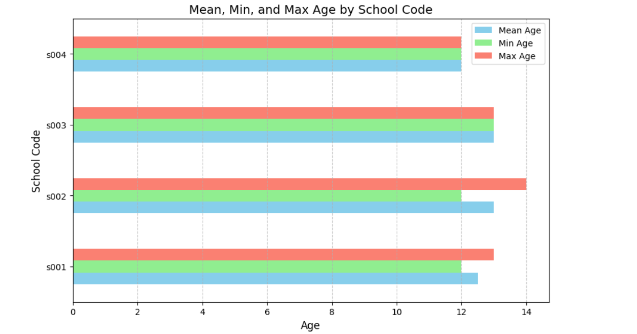

**Lab3: Write a Pandas program to split a dataset, group by one column and get mean, min, and max values by group. Using the following dataset find the mean, min, and max values of purchase amount (purch_amt) group by customer id (customer_id).Also generate a line chart based on the result and explain the conclusion.**

**Input:**

orders_data = pd.DataFrame({ 'ord_no':[70001,70009,70002,70004,70007,70005,70008,70010,70003,70012,70011, 70013], 'purch_amt':[150.5,270.65,65.26,110.5,948.5,2400.6,5760,1983.43,2480.4,250.45, 75.29,3045.6], 'ord_date': ['2012-10-05','2012-09-10','2012-10-05','2012-08-17','2012-09-10','2012-07-27','2012- 09-10','2012-10-10','2012-10-10','2012-06-27','2012-08-17','2012-04-25'], 'customer_id':[3005,3001,3002,3009,3005,3007,3002,3004,3009,3008,3003,3002],'salesman_id':[5002,5005,5001,5003,5002,5001,5001,5006,5003,5002,5007,5001]})

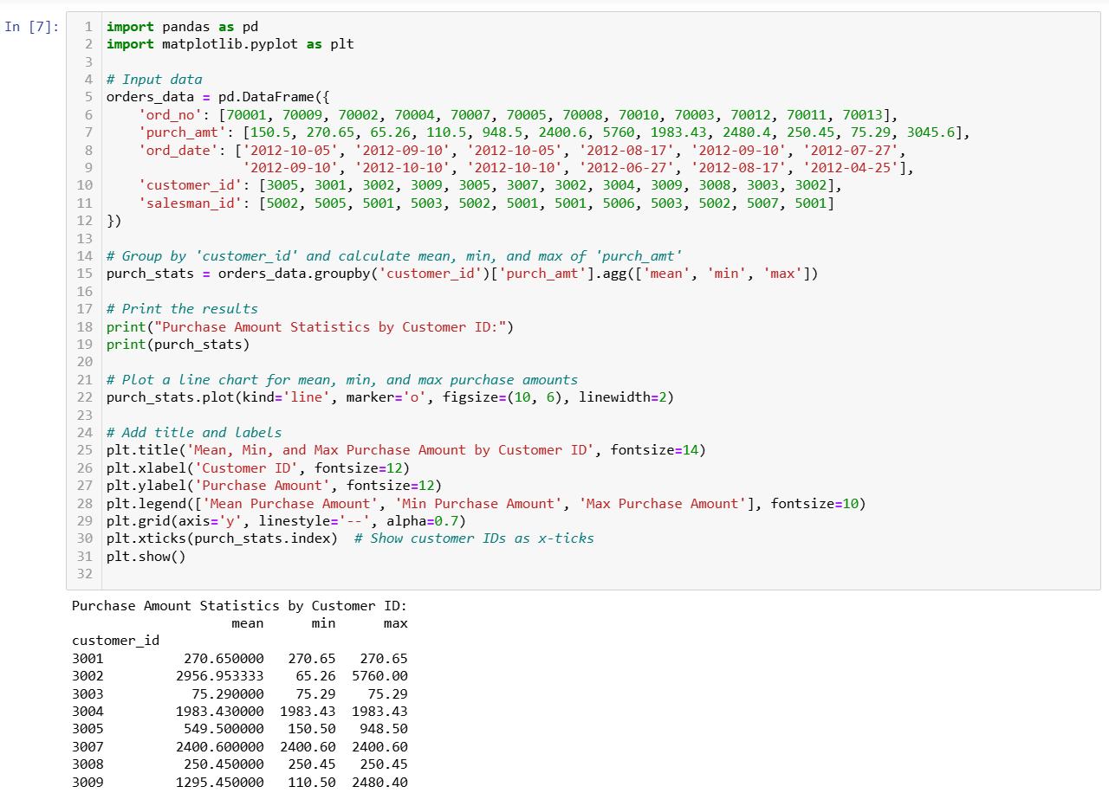

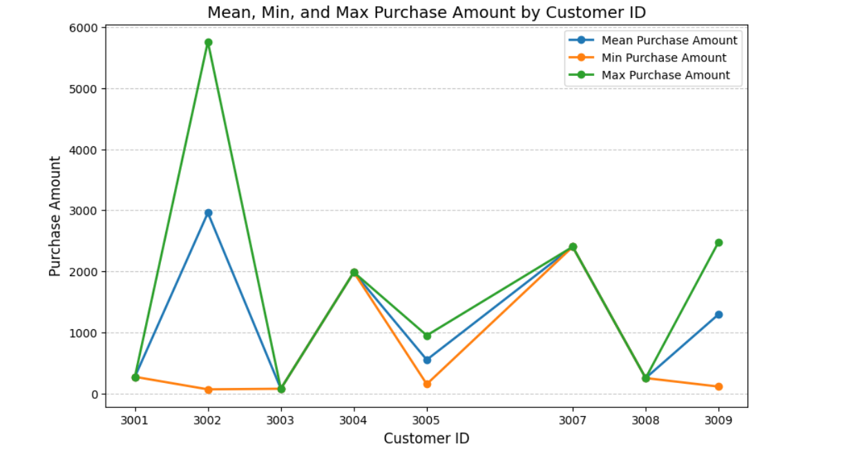

**Lab4: Write a Pandas program to split the following data frame into groups and calculate monthly purchase amount.Also generate a bar chart based on the result and explain the conclusion.**

**Input:** df = pd.DataFrame({ 'ord_no':[70001,70009,70002,70004,70007,70005,70008,70010,70003,70012,70011, 70013], 'purch_amt':[150.5,270.65,65.26,110.5,948.5,2400.6,5760,1983.43,2480.4,250.45, 75.29,3045.6], 'ord_date': ['05-10-2012','09-10-2012','05-10-2012','08-17-2012','10-09-2012','07-27-2012','10-09- 2012','10-10-2012','10-10-2012','06-17-2012','07-08-2012','04-25-2012'], 'customer_id':[3001,3001,3005,3001,3005,3001,3005,3001,3005,3001,3005,3005],'salesman_id':[5002,5005,5001,5003,5002,5001,5001,5006,5003,5002,5007,5001]})

